- = Does not require social security number to apply
COVID-19 resources do not count as public charge
FOOD RESOURCES

School Based Sites

- Mukilteo School District
Free “to go” meals will be available for any child at several sites throughout the district. Meals will include breakfast and lunch and will be available 11:30 a.m. to 1 p.m. Mondays through Fridays throughout the district closure.
Friday meals will include weekend breakfasts and lunches as well.
The lunches are free and available to any child whether they are in the district or not. Child must be present
Food allergies or veggie meal needed? Call: 425-356-1212 in advance for accommodations.

Meal sites:
- Challenger Elementary School, 9600 Holly Drive, Everett, WA 98204
- Columbia Elementary School, 10520 Harbour Pointe Blvd., Mukilteo, WA 98275
- Horizon Elementary School, 222 W Casino Road, Everett, WA 98204
- Mariner High School, 200 120th Street SW, Everett, WA 98204
- Mukilteo Elementary School, 2600 Mukilteo Speedway, Mukilteo, WA 98275
- Odyssey Elementary School, 13025 17th Avenue W., Everett, WA 98204
- Serene Lake Elementary School, 4709 Picnic Point Road, Edmonds, WA 98026
- Headstart of Snohomish County, 12811 8th Ave. W., Everett, WA 98275
Mobile meal routes:
- Walter E. Hall Park, 11:30 to 12:00 PM
- Fairmount Elementary, 12:15 to 12:45 PM
- Olivia Park Elementary, 11:30 to 12:00 PM
- Lake Stickney Elementary, 12:15 to 12:45 PM
- The Greens of Merrill Creek Apartments, 11:30 to 12:00 PM
- Puget Park Apartments, 12:30 to 1:00 PM
- Vantage Apartments, 11:30 to 12:00 PM
- Tamaron Ranch Apartments, 12:15 to 12:45 PM

- Everett School District

- Meals will be available for pick up. Lunch orders must be placed before 7:00 a.m. each day. Orders placed after 10:00 a.m will be for the following day.
- Preorder is encouraged each day
- https://docs.google.com/forms/d/e/1FAIpQLScDKtD8YgVrb1nZ4Oc0aIuGbyoof5gthnT4VFx-ukUzYDsK0g/closedform
- Meals will be free for all children 1-18 years of age (they do not need to be a student)
- Students must be present to receive their meal. Adult meals are not available for purchase
- Breakfast for the next morning will be given out with lunch
- Pick-up site does not need to be the students home school, you can select the most convenient site for your family.

FOOD RESOURCES CONT.

HOURS PLACES ADDRESS
11:30-11:45 Emerson Elementary 8702 7th Ave SE, Everett, WA 98208
11:30-11:45 Eisenhower Middle School 10200 25th Ave SE, Everett, WA 98208
11:15-11:30 Evergreen Middle School 7621 Beverly Ln, Everett, WA 98203
12:00-12:30 Family Tree Apts 10110 19th Ave SE, Everett, WA 98208
12:30-1:00 Gateway Apts 13105 21st Dr SE, Everett, WA 98208
11:00-11:15 Jefferson Elementary 2500 Cadet Way, Everett, WA 98208
11:15-11:30 Lowell Elementary 5010 View Dr, Everett, WA 98203
12:30-12:45 Madison Elementary 616 Pecks Dr, Everett, WA 98203
11:45-12:15 Mirabella Apts 805 112th St SE, Everett, WA 98208
11:15-11:30 Monroe Elementary 10901 27th Ave SE, Everett, WA 98208
11:45-12:15 Shoreside Village 701 75th St SE, Everett, WA 98203
11:15-11:45 The Lakehouse Apartments 12115 19th Ave SE, Everett, WA 98208
12:15-12:30 View Ridge Elementary 202 Alder St, Everett, WA 98208

Food Banks and More

Mukilteo Food Bank
Address: 4514 84th St.SW
Mukilteo, WA 98275
Service Hours:
2nd & 4th Monday 3:00pm - 5:30pm
2nd & 4th Tuesday 9:00am - 10:30pm
Phone: 425-366-8229
Website: legacy.mukilteofoodbank.org

- Grace Lutheran Church
Backpacks of food for all kids
Delivers food to those who have transportation barriers in the South Everett/Mukilteo Area

Address: 5425 Harbour Pointe Blvd.
Mukilteo, WA 98275
Service Hours:
Thursdays from 10:00 AM – 2:00 PM
5:30 PM – 8:00 PM

- The Village on Casino Road
Food Bank Pantry
Address: 14 E Casino Rd
Everett, WA 98208
Service Hours: Tuesdays
10:00 AM – 1:00 PM
Website: connectcasinoroad.org

- Snohomish County COVID-19 Mutual Aid
Groceries, supplies, and/or medicines delivery

https://docs.google.com/forms/d/e/1FAIpQLSejPxLmXv2oNqYTTcqh37YSmr-kLPGfbdxFqo0hokqZLj9iqw/viewform?vc=0&c=0&w=1&fbclid=IwAR3OIjFgmtPcklfEdgFqGRoM6JwZEGQf_uC01ywv78TFSLHf3JqwGjrJoWE

Community Organizations

- Hand In Hand
Boxed food, household supplies, diapers/wipes toiletries, community navigation, etc.
Address: 9502 19th Ave SE suite f, Everett, WA 98208
Hours: 8:00 AM – 5:00 PM Monday through Friday
Phone: (425) 374-2461

HOUSING AND UTILITY ASSISTANCE
Rental Assistance

- Relief fund for undocumented individuals in Washington State
https://docs.google.com/forms/d/e/1FAIpQLSeBKrXPUghTKPdzGkaZ6c5uCVho_HfG6eMQAyw_s_U6iaIjMg/viewform

St. Vincent De Paul
May assist with a one-time assistance for rent $200 max
- The Project PRIDE: Project PRIDE offers grants when available for low-income clients that can be used for paying various housing expenses, whether it is an energy bill or even a security deposit on a new, low income apartment. Project PRIDE offers grants of up to $125 and has income guidelines. Applications can be submitted at the Broadway location office or mailed in to the mailing address listed below. Must Provide: Completed Application, Proof of income for all household members within the last 30 days, and disconnection notices in the applicants name.
Project Pride (425) 374-1243
Assistance Line: (425) 355-3504 - (Option 3) for intake.
Monday- Friday (9:30 am- 4 pm)
Mailing Address: PO Box 2269 Everett, WA 98203

Volunteers of America
Can assist with one-time payment assistance or guidance to other financial resources available.
*Financial assistance is dependent on funding*

211 hotline (requires social security number)
- Arlington Resource Center - (360) 386-7989
Utility Assistance

- Free Internet through Comcast for 60 days for low-income families
Only $9.95 a month after the 60 days – no installation/credit or cancellation fee.
You may be eligible for a low cost computer - $149.99
https://www.internetessentials.com/

- PUD low-income assistance.
PUD will NOT be disconnecting customers for non-payment during this time.

For the Community Support Plan, please call PUD at 425-783-1000 (Monday-Friday, 8 a.m. to 5:30 p.m.)
PUD offers year-round income-qualified rate discounts of 20, 40 or 60 percent off PUD electric and water bills to customers based on the total household income limits. https://www.snopud.com/Site/Content/Documents/custpubs/lincapp15_web.pdf
- PSE Low-Income Assistance
PSE will NOT be disconnecting customers for non-payment
The federal Low-Income Home Energy Assistance Program (LIHEAP) provides financial assistance to eligible low-income households to help pay their winter heating bills.
https://www.pse.com/pages/bill-and-weatherization-assistance

EDUCATION FOR KIDS AND CHILDCARE
Education Resources

Mukilteo School District online tools:
https://www.mukilteoschools.org/Page/14237
Everett School District online tools:
https://www.everettsd.org/Page/31233
Scholastic Free learning for kids’ PreK-9
https://classroommagazines.scholastic.com/support/learnathome.html
Educational podcasts for kids:
https://app.kidslisten.org/

Online Learning Tools
https://www.weareteachers.com/?fbclid=IwAR094LOGuOVv31mec130ddl2zhEcsTlDRyz7uaExfKkJY3lcszmumj44YiY
Education for parents and kids:
https://edu.gcfglobal.org/en/topics/
ChildStive online learning:
https://www.facebook.com/ChildStrive/
CDC guidance for schools and childcare programs:
https://www.cdc.gov/coronavirus/2019-ncov/community/schools-childcare/index.html

Childcare

- Boys and Girls Club
$25 per day/$125 per week. Free childcare for front line healthcare & first responder’s children.
Address: 525 W Casino Rd. Everett, WA 98204
Phone: 425-355-6899
Hours of Service: 6:00 AM – 6:30 PM

- YMCA

The Y has all-day, quality childcare available for children ages 6 weeks to 13 years. Children are provided breakfast, a mid-morning snack, lunch and an afternoon snack.

YMCA Early Childhood Education
The YMCA of Snohomish County’s Heatherwood Early Childhood Education Center serves infants ages 6 weeks through children preparing for kindergarten. If this is a service you are in need of please phone or email Jennifer Grandemange at 425/379-9400 jgrandemange@ymca-snoco.org. Heatherwood Child Care: 13528 N Creek Dr. Mill Creek, WA 98012; hours 6:30a-6:30pm

https://ymca-snoco.org/emergency-childcare

HEALTH AND WELLNESS
COVID – 19 Assistance

Mukilteo School District: https://www.mukilteoschools.org/domain/2486
Everett School District: https://www.everettsd.org/Page/31102
Snohomish County: https://www.snohomishcountywa.gov/AlertCenter.aspx?AID=Snohomish-County-COVID19-response-Restri-136
Washington Department of Health: https://www.doh.wa.gov/Emergencies/Coronavirus
- Alien Medical Assistance: https://www.hca.wa.gov/health-care-services-supports/forms-and-publications?combine=AEM&field_free_topic_tid=All&field_free_document_type_value_1=Publication&sort=filename+ASC&=Search
Physical Activities

YMCA – At Home
Virtual Exercise Classes: Tune in to exclusive virtual exercise classes hosted by some of our favorite instructors. These 20-minute workouts will help keep everyone in your home active and moving. Even the kids!
https://ymca-snoco.org/y-at-home/
Mental Health and Domestic Violence

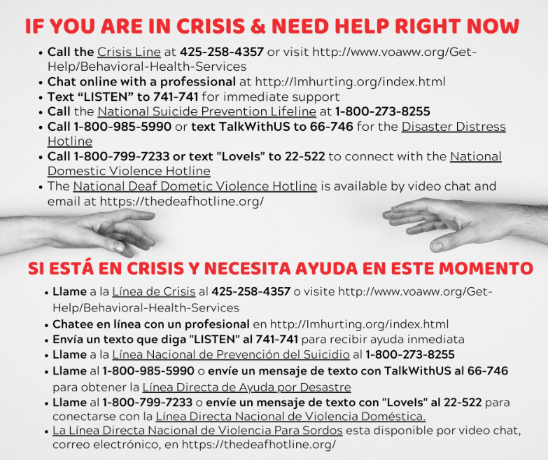
- Adolescent Mental Health Program (Snohomish County)
Smokey Point Behavioral Hospital offers an Adolescent Mental Health Program (inpatient treatment for teens). You can call 844-202-5555 for a consultation and to set up a free assessment 24/7.
Anyone may call the VOA Care Crisis Response Services at 1-800-584-3578. This service is always available. A licensed mental health professional will assess the situation, make appropriate referrals, and/or dispatch the MCOT community based outreach team.
Providence Sexual Assault Crisis Line: (425) 252-4800
Child Protective Services (CPS):
(866) 829-2153

OTHER ECONOMIC RESOURCES

Legal status not required

- Washington Disaster Cash Assistance program:
Helps low-income families who do not receive any other DSHS assistance already. No social security needed.
https://www.washingtonconnection.org/home/
- COVID-19 Relief Fund for Undocumented Individuals in Washington State:https://docs.google.com/forms/d/e/1FAIpQLSeBKrXPUghTKPdzGkaZ6c5uCVho_HfG6eMQAyw_s_U6iaIjMg/viewform

Support for small business

Washington State Department of Financial Institutions:
https://dfi.wa.gov/coronavirus-small-business-resources
PUD assistance for business owners:
https://www.snopud.com/newsroom.ashx?p=1102&173_na=406&fbclid=IwAR1oCSxVq1c9RLJAzwuQ70EAtYSor9dlkhJRdL1KeUB92bx0-Wb8mZOy3pk
- City of Everett:
Way for small food businesses to advertise to-go sales
www.everettforeverett.com
Unemployment for workers and business affected by COVID-19:
https://esd.wa.gov/newsroom/covid-19

